LAB-1 INTRODUCTION TO PYTHON

1. INSTALLING PYTHON ON WINDOWS

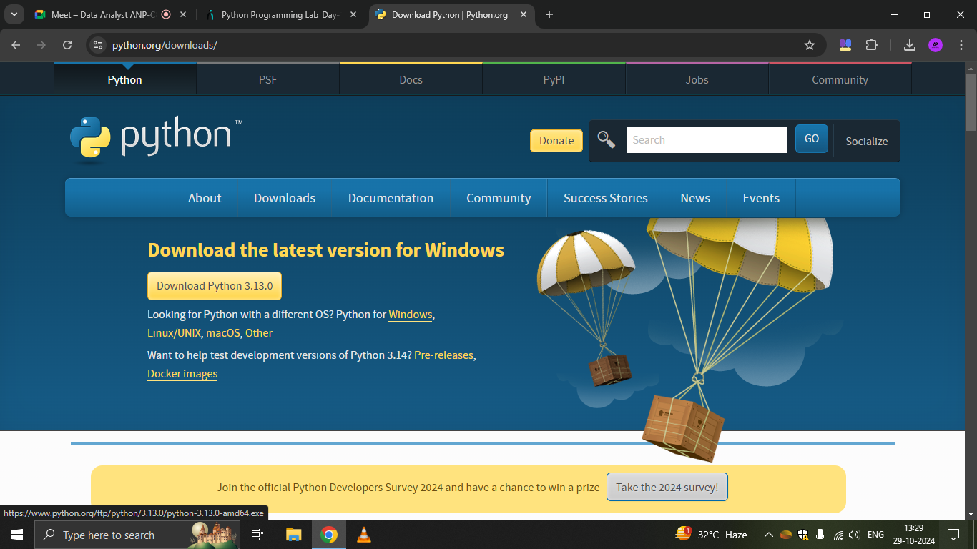

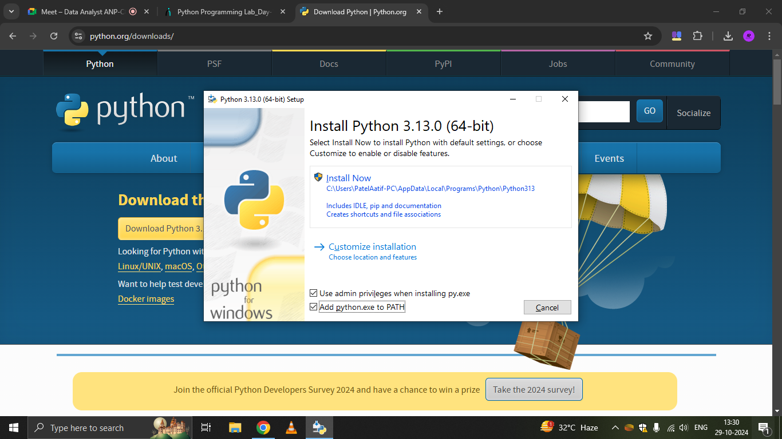

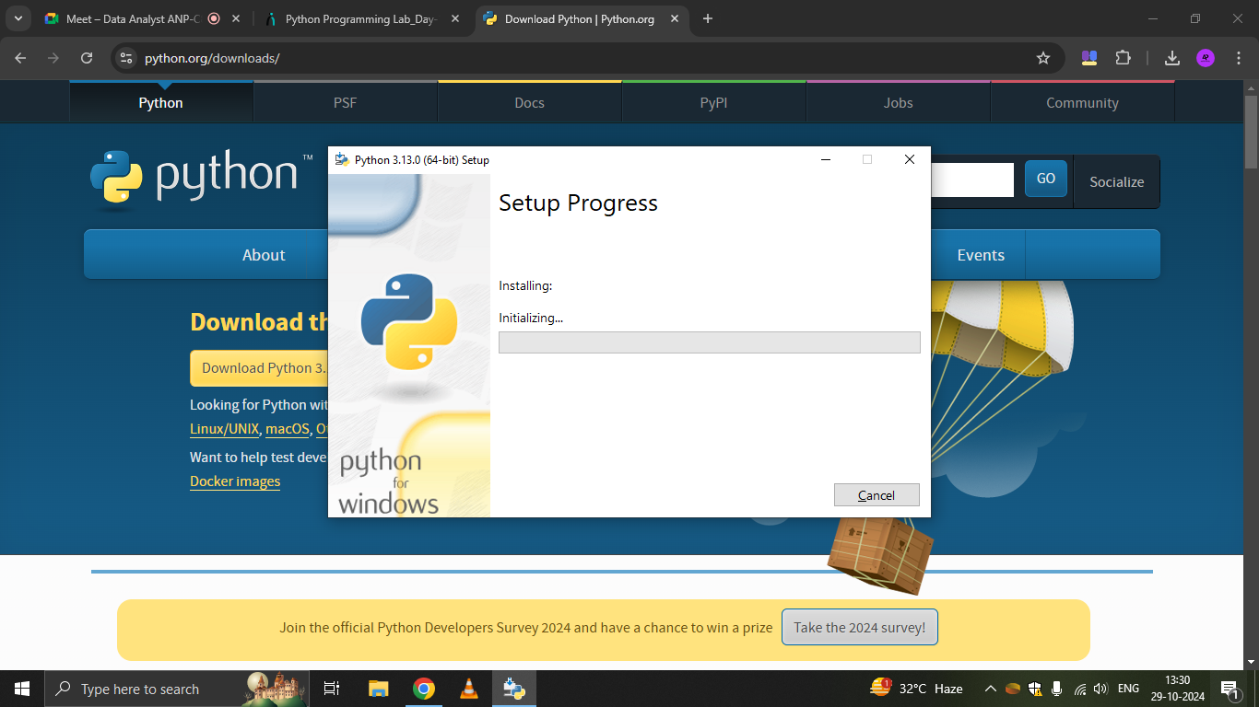

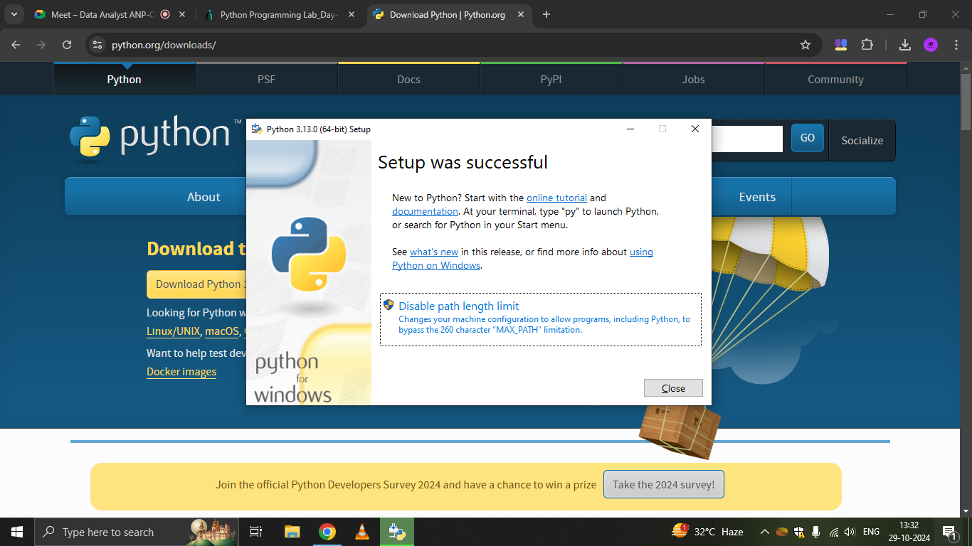

2. Demonstrate about Basics of Python Programming:

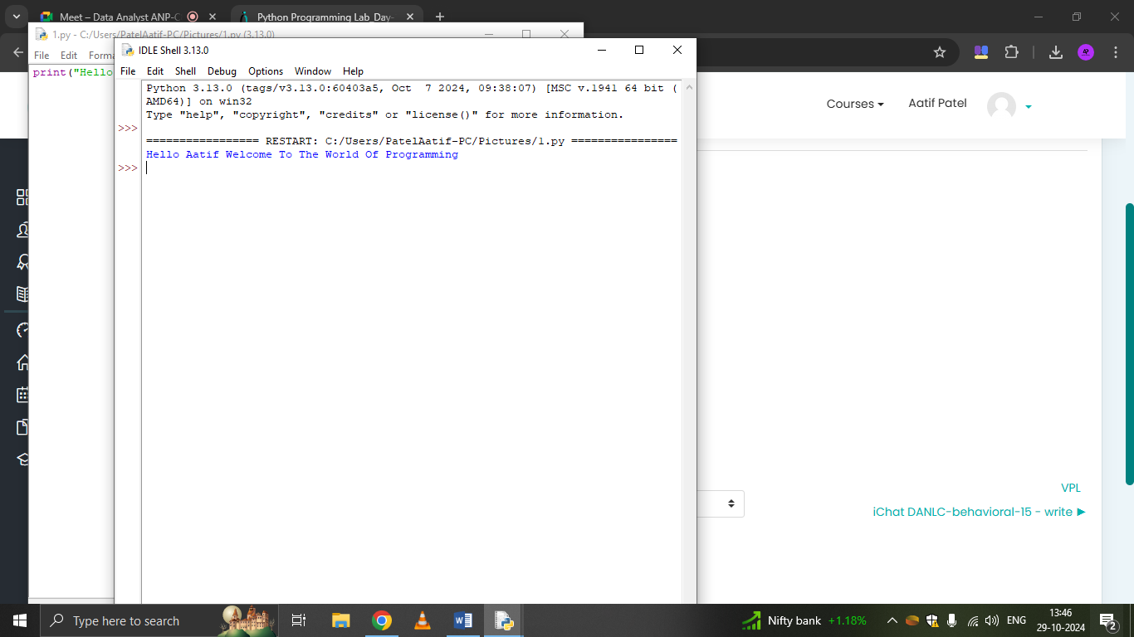

In the basics of Python programming, the print() function is a fundamental command used to display output to the screen. For example, in the provided code, the line

print("Hello Aatif Welcome To The World Of Programming") outputs a greeting message to the console. Python's syntax is simple and readable, making it an ideal language for beginners to start learning programming concepts.

1. Running Python Interpreter:

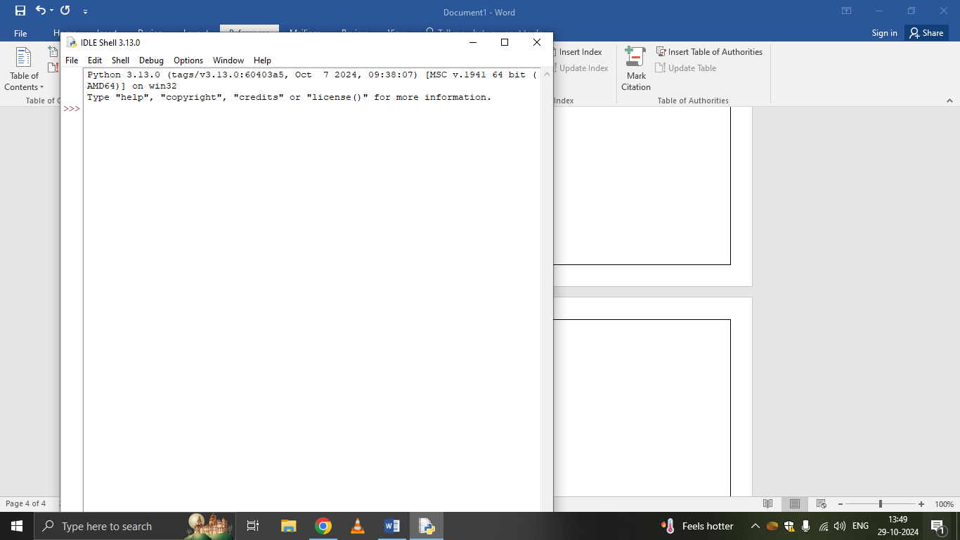

1. Running Python Scripts in IDLE (Integrated Development and Learning Environment):

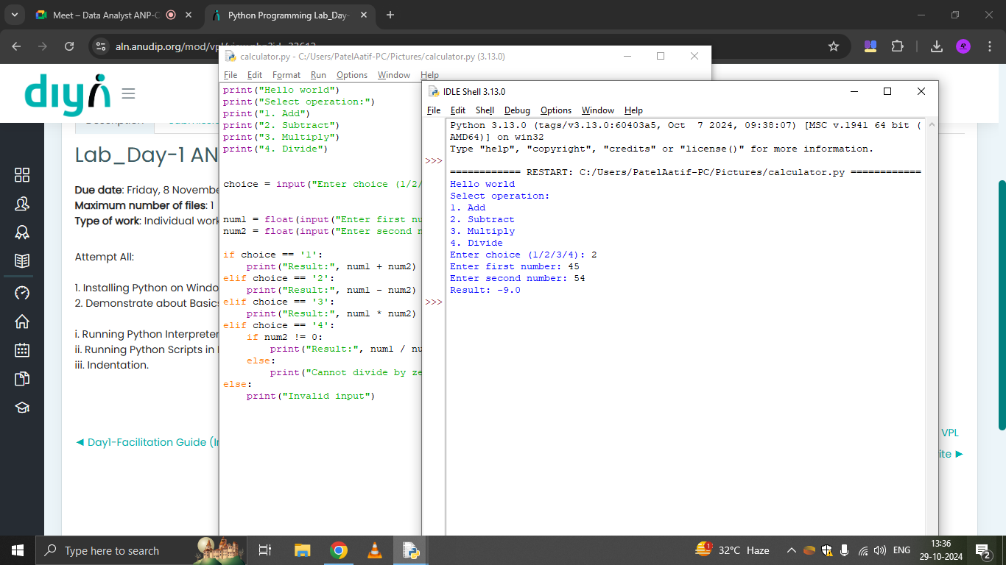

1. Indentation.

